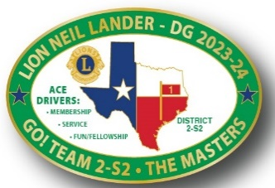 

**District 2-S2 4th Cabinet Meeting**

June 8, 2024

1. Welcome
2. Prayer – District Chaplain Bill Hogan
3. Pledges – FVDG-E Mike George
4. Quorum? 3rd Cabinet Minutes Approval – Lion Marla and Secretary Minette
5. DG Comments and District Goals Review – Lion Neil
6. Disaster Relief/Grants – Lion Neil
7. Financial Updates – Treasurer Ralph Perez
8. GAT-D Highlights in the Year in Review
   1. GLT-D PDG Lisa Free-Martin (MD-2 Training)
   2. GET-D PDG Mark Roth
   3. GMT-D Emee Nisnisan
   4. GST-D Patti Dugan
   5. GMT-D Coordinator - Club Enhancement Support – Phyllis Thomas
   6. GMA-C FVDG Bill Simpson
9. TLC – Directors – Lions Kari and Shelia
10. HRF – Chair DG-E Bill
11. Opportunities for Youth – PDG Rick and Lion Marla Reynolds
12. LEO Tina Ly – Her LEO Experience Update (If she can make it.)
13. LEO District, New Club Update and LEO District Council – Nancy Chesbro

**Break – 15 Minutes**

1. Convention Election Results – PDG Chuck Martin
2. Zone Chairs – The MASTERS – Zone Club Highlights
   1. M-1 Kevin Smith
   2. A-1 Bill Hogan
   3. S-1 Suzie Vestal
   4. T-1 Dr. Anthony Price
   5. E-1 Valarie James
   6. R-1 John Tankersley
   7. S-2 Carol Barnett
3. Club Excellence Criteria – Lion Neil
4. Mission 1.5 – District Membership Incentives –Second Review - Lion Neil
5. LCIF Update – IPDG Paul Moore
6. New LCI Portal Update and District Communications – PDG Tony Austin
7. DG-E Bill Forward Plans. District SWAT Highlights, New Cabinet, District Goals, etc.